Analysis Document
Description of Site Design
I have taken inspiration from the steam website https://store.steampowered.com to create my theme with the same colour theme. Moreover, I used an identical menu style, and I have decided to use the Steam logo as the main signature of my page. After that, I decided to put my navigation menu on the left-hand side of the page which is easily accessible.

Wire Frames
This is the two layout I used
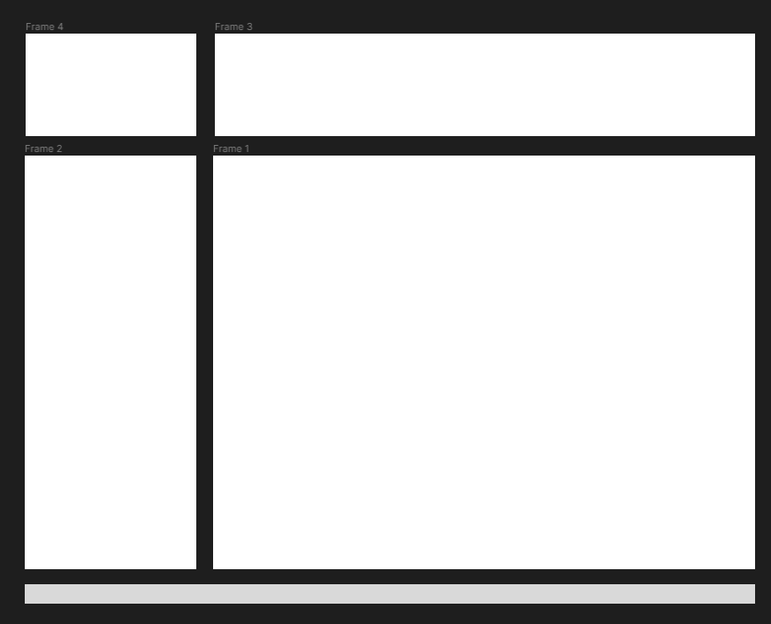
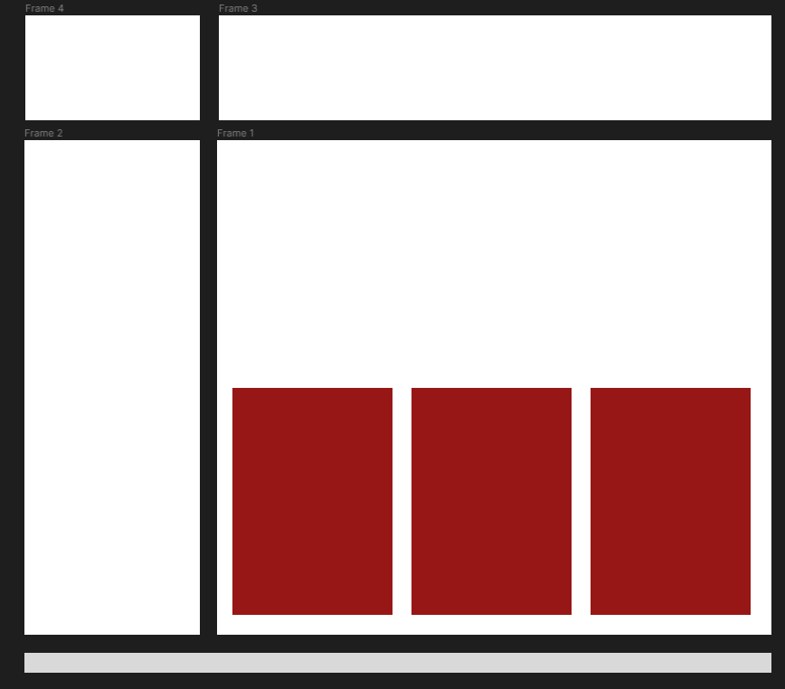

Site Map Diagram
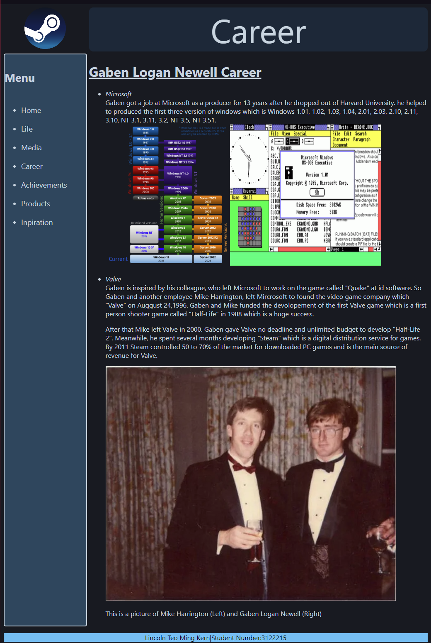
This a diagram of my webpage. I have decided to put my navigation menu on the left-hand side of the page for easy access. I used Grid for the main page and flex box for the middle info page.
Researches
Creative Minds: Gabe Newell (no date). Available at: https://web.archive.org/web/20141211153904/http://www.computerandvideogames.com/172835/interviews/creative-minds-gabe-newell/.
Gabe Newell (no date) Half-Life Wiki. Available at: https://half-life.fandom.com/wiki/Gabe_Newell (Accessed: 25 January 2024).
Gabe Newell’s LinkedIn (no date). Available at: https://www.linkedin.com/in/gabenewell.
Chiang, O. (no date) Names You Need to Know in 2011: Gabe Newell, Forbes. Available at: https://www.forbes.com/sites/oliverchiang/2010/11/13/names-you-need-to-know-in-2011-gabe-newell/ (Accessed: 25 January 2024).
Technology Billionaires (no date) Forbes. Available at: https://www.forbes.com/richest-in-tech/list/ (Accessed: 25 January 2024).
The Final Hour’s of Half-Life 2 (no date). Available at: http://www.gamespot.com/articles/the-final-hours-of-half-life-2/1100-6112889/.
The Master of Online Mayhem (no date). Available at: http://www.forbes.com/forbes/2011/0228/technology-gabe-newell-videogames-valve-online-mayhem.html.
Valve’s Gabe Newell to be Honoured with BAFTA Fellowship (2013). Available at: https://www.bafta.org/media-centre/press-releases/valves-gabe-newell-to-be-honoured-with-bafta-fellowship (Accessed: 25 January 2024).
Soper, T. (2012) Welcome to the Hall of Fame, Gabe: Valve founder inducted to Academy of Interactive Arts & Sciences, GeekWire. Available at: https://www.geekwire.com/2012/gabe-newell-award-hall-of-fame/ (Accessed: 25 January 2024).
Steam Store (no date). Available at: https://store.steampowered.com/ (Accessed: 28 January 2024).

